Handling elements and learning various selector strategies:
- If element has ID we can locate the element using #<id>
- We can also locate an element using n[attribute=’value’]
- We can locate using element name and then we can filter by text. <element>:has-text(‘text’).
We can get the text of an element using innerText() function.
We can also set delay in typing using new TypeOptions().setDelay(100) within the type method.
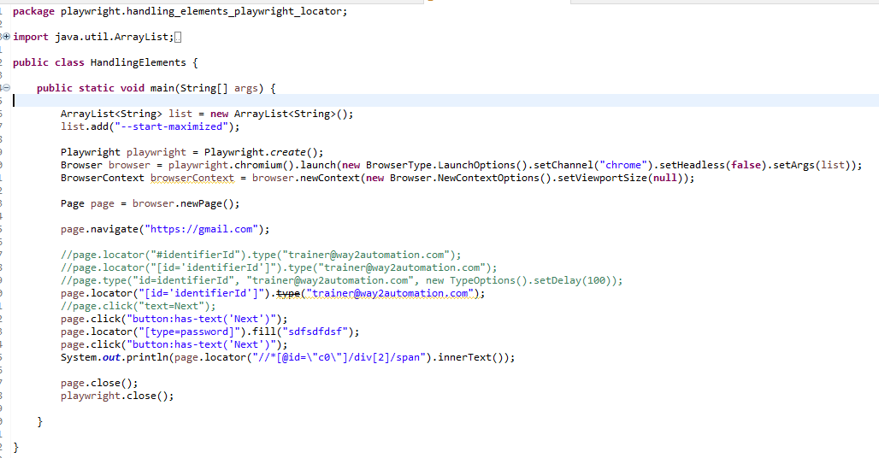
Playwright Record and Play – Test Generator:
https://playwright.dev/java/docs/codegen
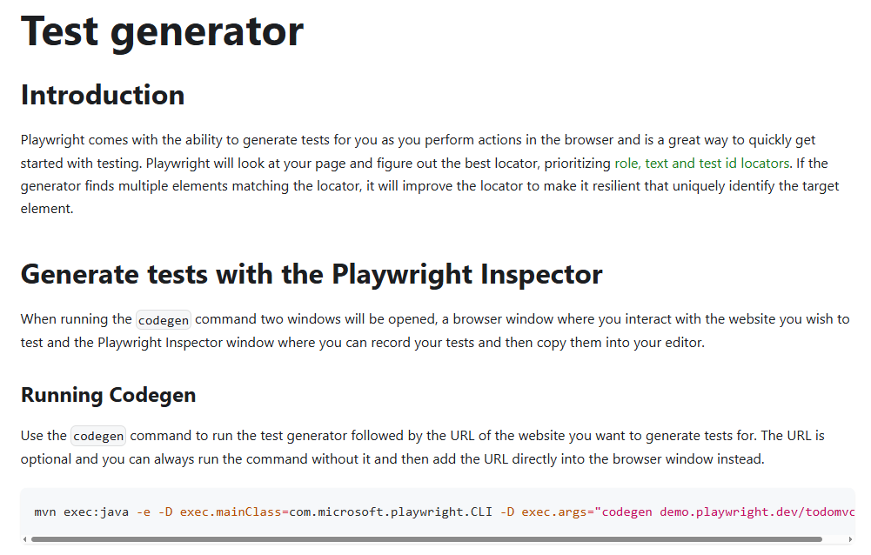
Execute the command: mvnexec:java -e -D exec.mainClass=com.microsoft.playwright.CLI -D exec.args="codegendemo.playwright.dev/todomvc"
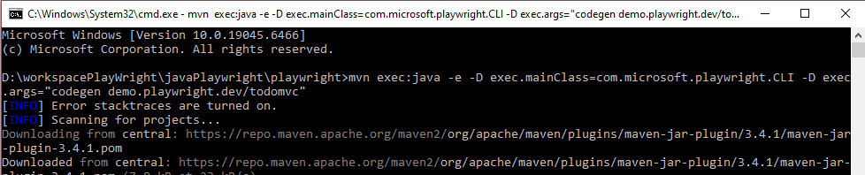
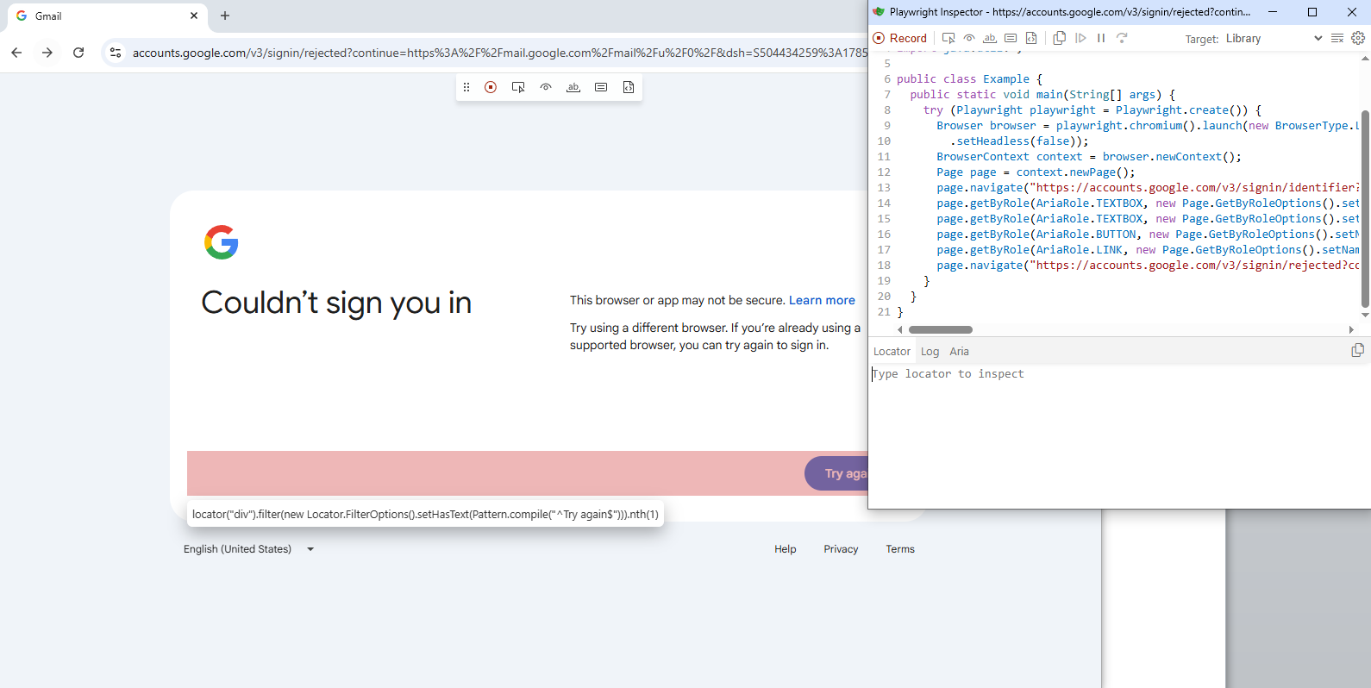

Handling dropdownList:
We can select element from dropdown box using value, index and text.
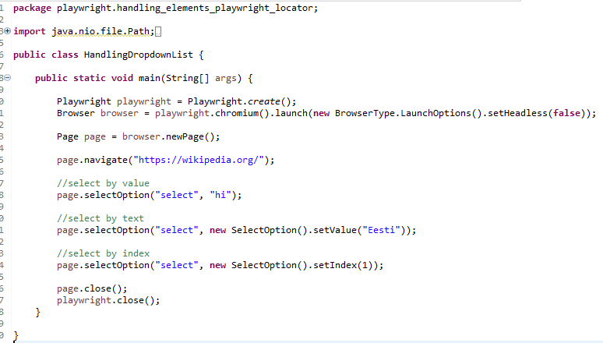
Handling Links:
Here we grab the list of object in locator class and iterate through it.
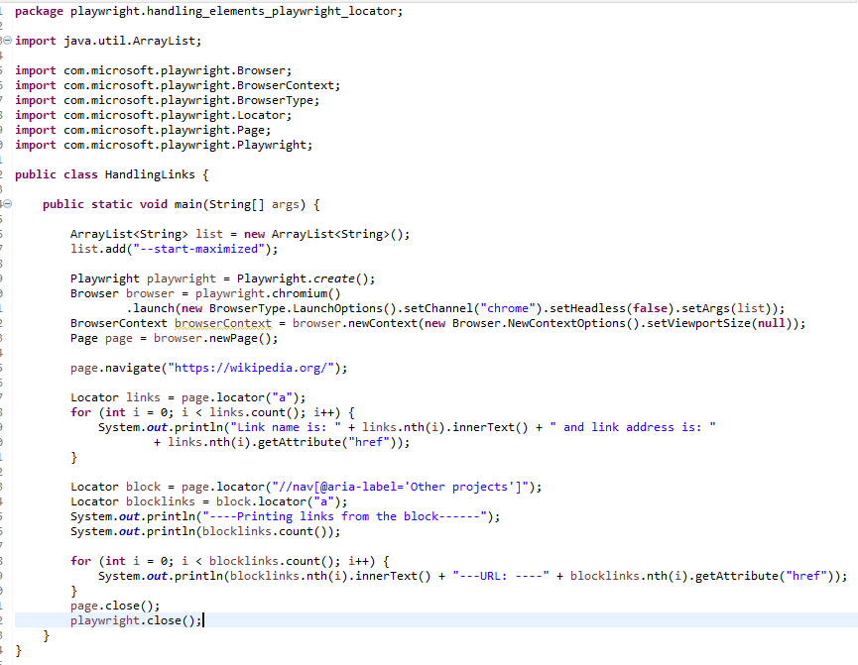

Handling checkboxes:
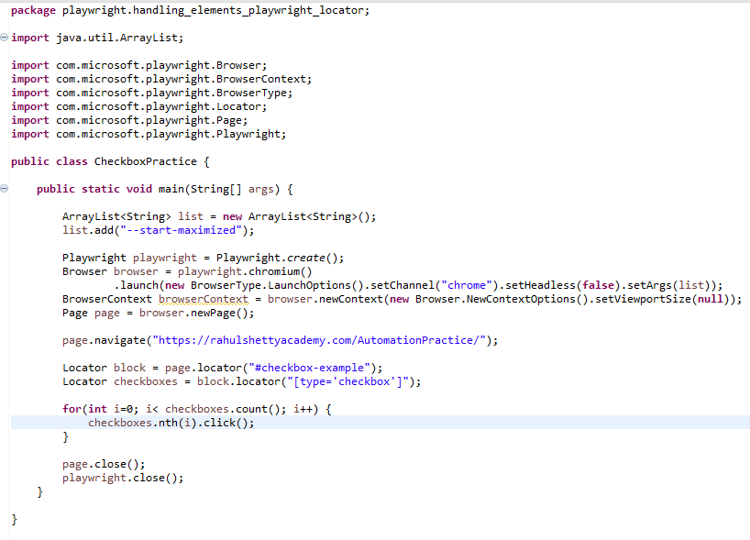

Handling alerts:
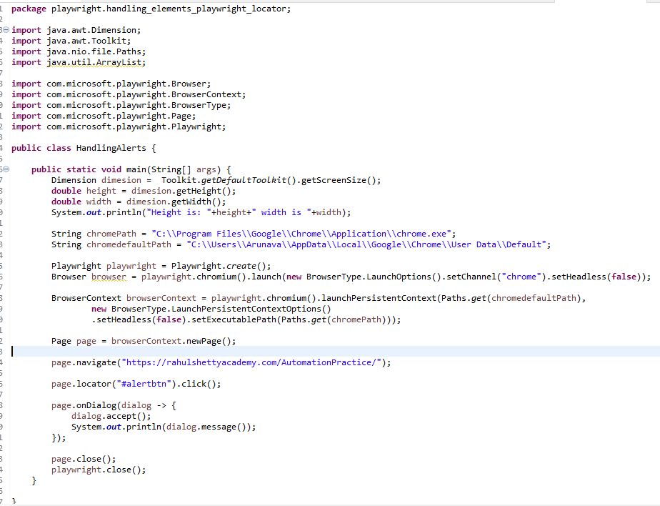

Handling frames:
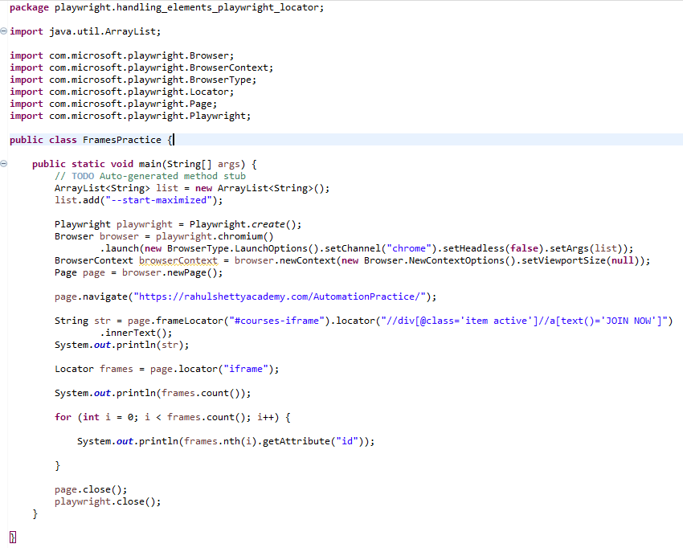

Handling tabs and popups:
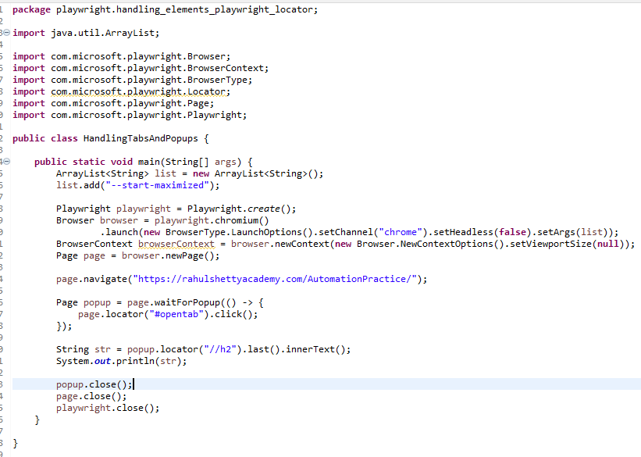

Mouse Hover:
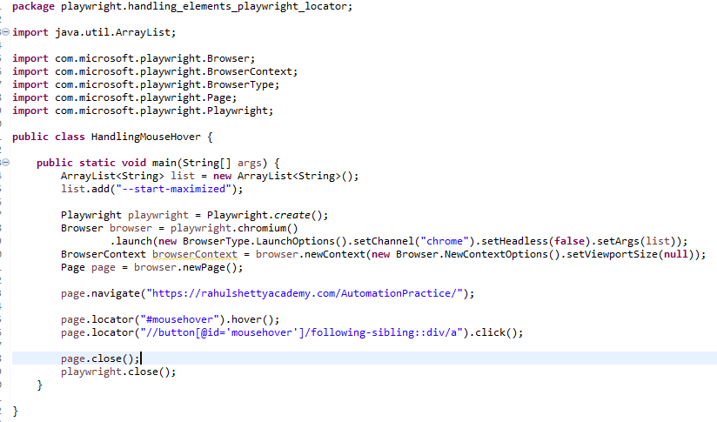

Handling shadow elements:
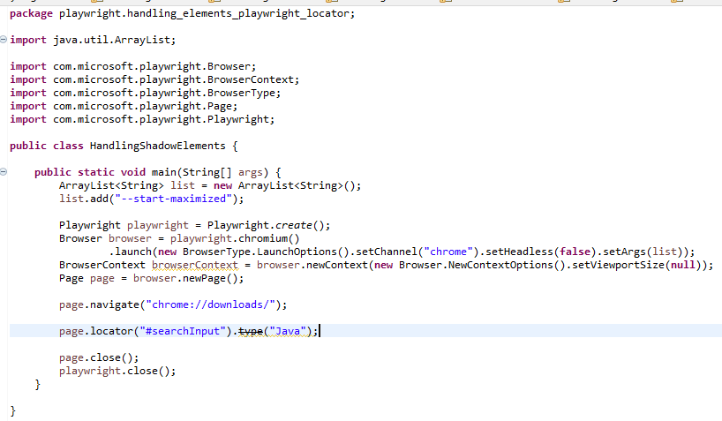

Executing Javascript code:
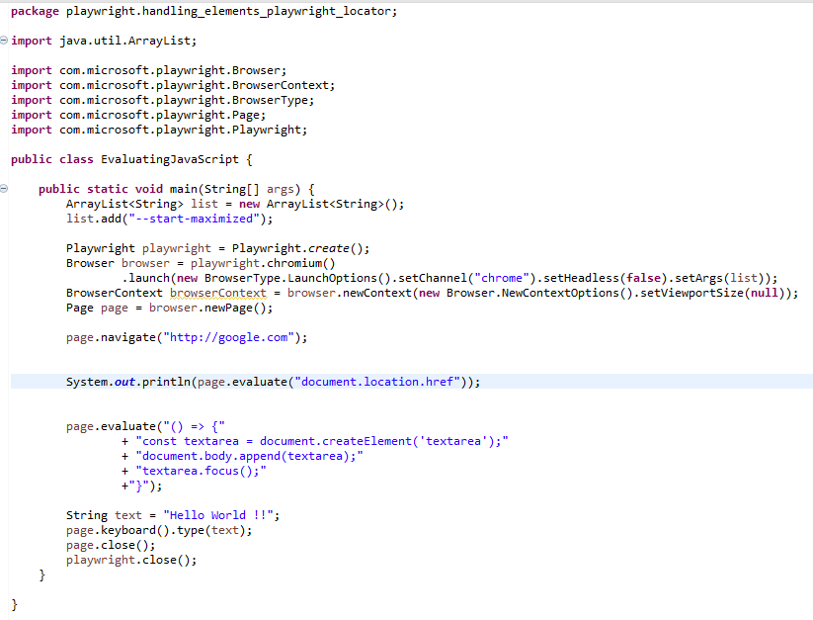

Handling Keyboard Events:
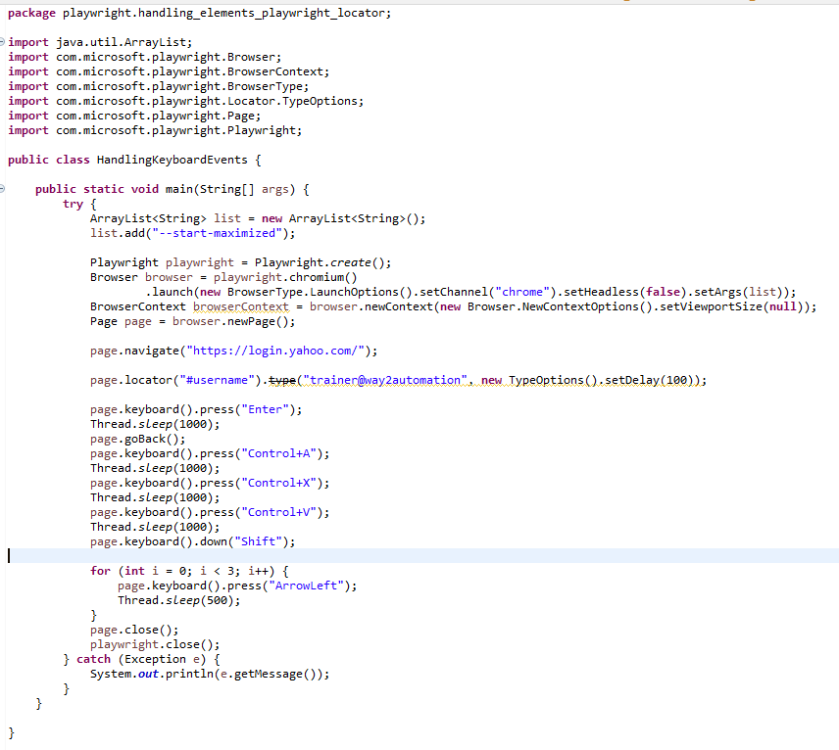

Uploading file:
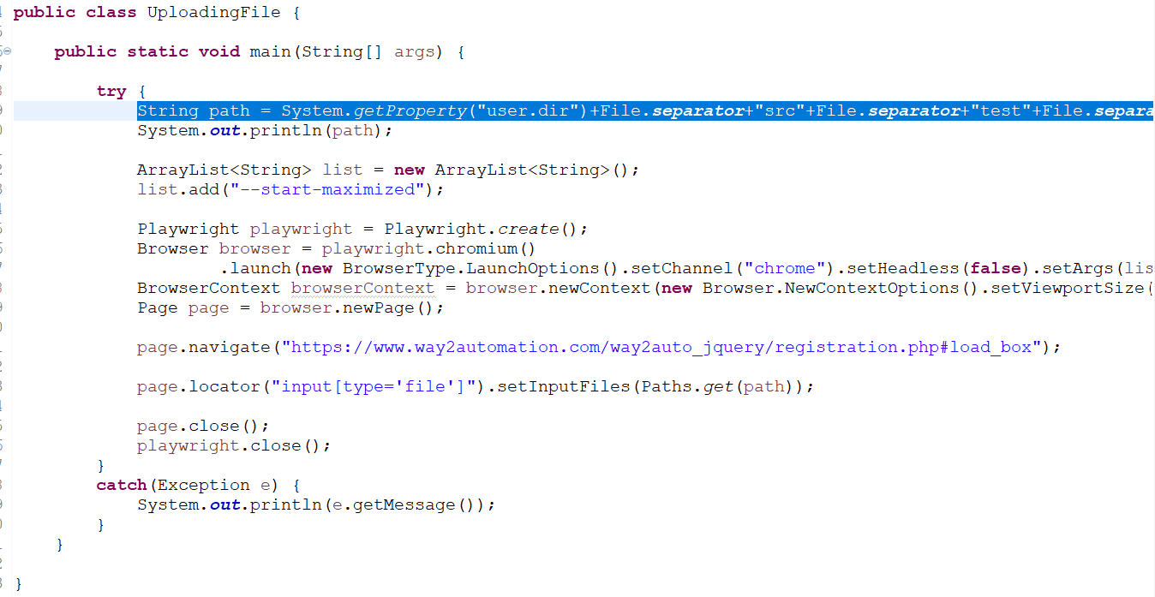

Uploading multiple files:
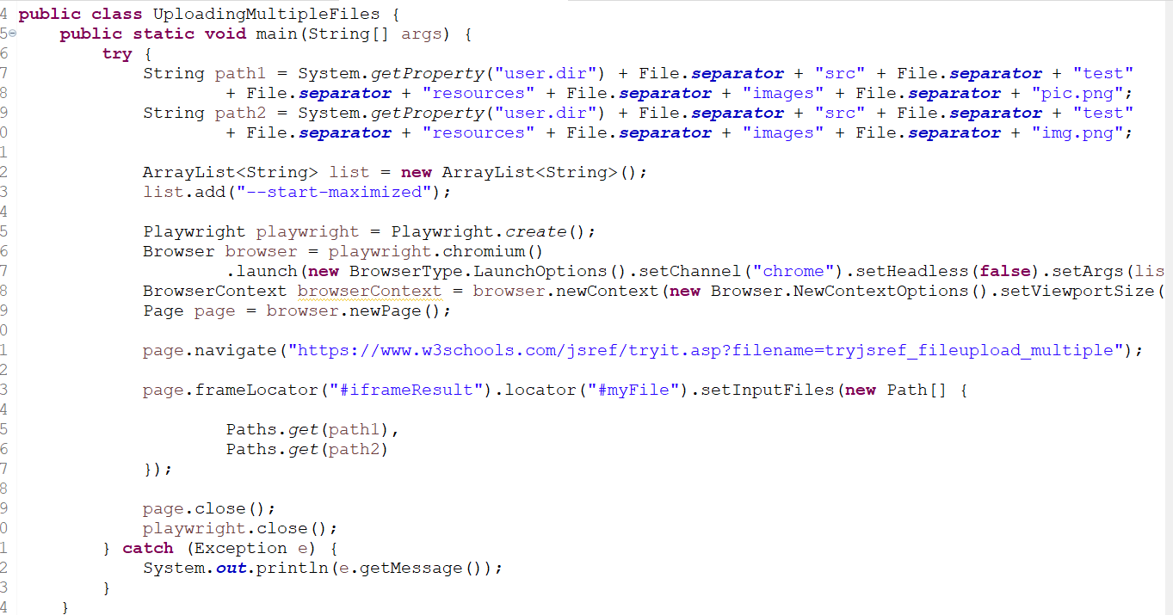

Download Files:
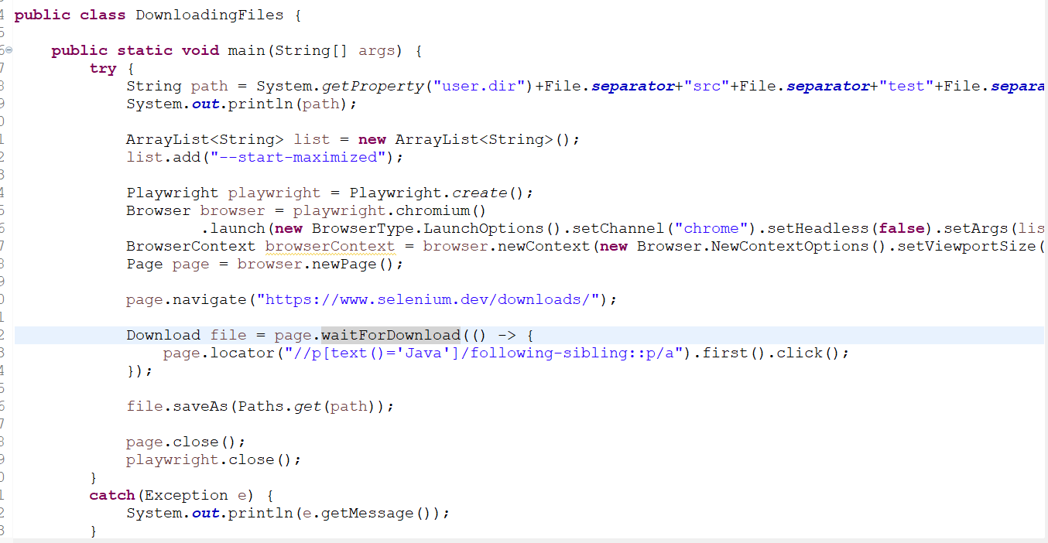

Handle Basic Authentication:
